Configuration | HP 24-cb0136m | HP 200 G4 21
Picture | 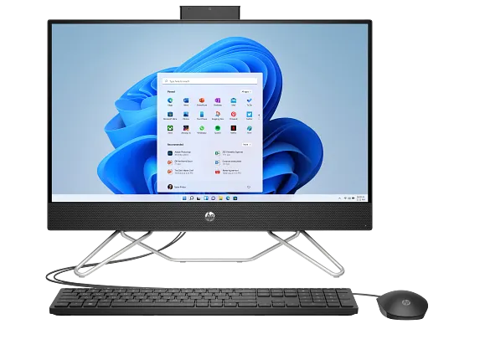 | 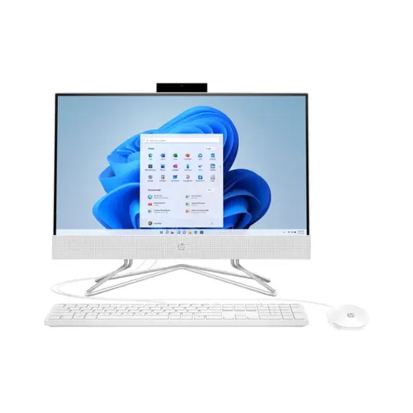
Processor | Intel Core I3-1215U | Intel Core I3-10110U
RAM | 8GB | 4GB
Hard Disk | 512GB HDD | 1TB HDD
Display | 24 FHD | 21.5 FHD
VGA | Intel Iris Xe Graphics | Intel UHD Graphics

